Smart Cents Weekly
Modern Financial Education for Young Investors
Week 3 • August 17, 2025

Contents: Welcome | Market Analysis | Our Picks | Educational Insights | Using Tools | Thank you
Powered by Meridian Research

Welcome 👋

This is MeridianAlgo’s third financial newsletter. If you’re returning from our first or second edition, thank you for coming back; we dedicate ourselves to educating young investors and supporting our community in any way we can, which means a lot to us. If you're new here, welcome! In this document, you'll find MeridianAlgo's insights on the US stock market, designed to boost your financial knowledge and investment skills for a brighter future. Our analysis is powered by proprietary machine learning algorithms, which you can see at the bottom of this document, along with our preferred charting platform: TradingView. We hope the market insights shared here, covering the past week and upcoming weeks, will help you better understand how markets really work and what happens behind the scenes.

What's Happening with the Market❓
Looking Overall
The S&P 500 gained about 1.3% this week, climbing from roughly 6,373 points (the market’s “score” at the start of the week) to a record close of 6,466.58 points on August 13. During trading hours, it even reached an intraday high of 6,480 points, meaning the highest point it hit before the market closed for the day. This strength came even though July’s producer price index (a measure of wholesale inflation) came in hotter than expected, which briefly worried investors that the Federal Reserve might delay cutting interest rates. Tech leaders, especially Amazon, helped steady the market and keep it near record highs. We view the current backdrop as cautiously optimistic: volatility is down, investor sentiment remains firm, and solid earnings support economic momentum. While inflation may slow progress, we see ongoing opportunities for disciplined investors, especially if expectations for a September rate cut hold.
Current Market Snapshot
The market has shown a steady upward trend over the past week, with all major indices hovering near highs. Investor confidence remains elevated, and buying interest has persisted even after brief pullbacks. This pattern suggests a balanced environment, where optimism outweighs fear, but not to the point of overextension. Strong participation from large-cap tech has provided stability, while broader participation across sectors hints at healthy underlying demand.
Volatility Check
The VIX has dropped sharply from around 15.08 earlier in the week to 14.5, marking its lowest level of 2025. This decline signals reduced market fear and more predictable trading conditions. Commentary on social media points to short covering after small dips, which is helping to suppress volatility and maintain upward momentum. Historically, periods of low VIX align with steady, gradual gains—though they can also precede sharper pullbacks if complacency sets in.
What Should You Do
For young investors, this is an ideal time to strengthen long-term habits. With over half of S&P 500 stocks trending positively, the environment supports steady accumulation rather than short-term speculation. Focus on consistent contributions, especially through low-cost index funds, and avoid being swayed by short bursts of economic data or market noise. Build an emergency fund before going heavy into investments, and remember that time—not perfect timing—is your greatest advantage. Bottom line: Use calm markets to develop a consistent investing discipline, making education and routine your priorities.

Our Picks and Historical Data ⛏️

Last week, we provided you with these picks for the following week to consider for your portfolios along with research. Now, looking at them, you can see how our predictions unfolded:
Stocks | % change (since previous Friday)
AAPL | +1.74%
MSFT | -0.28%
META | +1.40%
NFLX | -0.59%
UBER | +1.42%
JPM | +0.61%
SBUX | +2.24%
All predictions are uncertain. Use these insights as part of your broader research process.

Analysis of seven popular stocks based on current and past market conditions. All predictions are for the next six months and should be part of your broader research process. We also reviewed the previous stocks that we considered top choices for continued investment:

- AAPL: Sideways in the short term due to market consolidation. Bullish long-term as the iPhone 17 lineup will be announced in mid-September, and new tech (e.g., AI integrations) and software updates are expected to boost sentiment from August to January. Indicators like RSI and MACD suggest upside.
- MSFT: Sideways short-term, reflecting recent 11% dip and stabilization. Long-term, AI advancements (e.g., Copilot, cloud growth) and strong fundamentals support steady gains. Tech sentiment and economic recovery bolster outlook, though volatility may persist if macro concerns linger.
- META: Sideways short-term, backed by technicals like moving averages. Long-term, growth driven by ad revenue and metaverse/AI initiatives, though less dependent on "Magnificent Seven" hype. Market sentiment and user engagement trends are key for sustained upside.
- NFLX: Sideways in the short term, with technicals showing limited movement. Long-term growth depends on subscriber retention and the strength of the content slate. Consumer spending habits and competition in streaming weigh on the outlook, but no major catalysts are seen for a significant breakout.
- UBER: A 7.9% short-term increase is expected, driven by strong earnings and technical signals such as breakout patterns. Over the long term, growth will benefit from rising mobility demand and cycles of technological innovation. Urbanization and gig economy expansion provide additional support, although regulatory risks still exist.
- BLSH: Short-term bullish, with technicals indicating stability. Long-term, crypto partnerships (e.g., blockchain initiatives) and resilient financials support modest growth. Sensitive to interest rate changes and economic confidence, but diversified revenue streams ensure stability.
- NVDA: Sideways short-term, aligned with indicators like volume trends. Long-term, tied to consumer discretionary spending and global trade pushes. Economic recovery supports gradual growth, but inflation or reduced consumer confidence could cap upside. No major product catalysts noted; however, deals with the US government aim to put the potential for upside of this stock.

All predictions are uncertain. Use these insights as part of your broader research process.

Money Basics 🧗
Recap
Last time, we covered the basics of investing, from diversifying across asset classes, regions, and sectors to choosing cost-effective, secure tools with reliable real-time data and researching industries and market trends to make smarter stock decisions. These are powerful strategies once you are in the market. However, before you can put your money to work, you need to have money set aside in the first place. This is where budgeting comes into play.
Why Budgeting Works?
- Gives you control: Allows you to track where money is coming from and going to
- Keeps spending in check: Prevents overspending and unnecessary debt
- Prevents Dipping Into Investments: Keeps daily expenses covered so you don’t have to sell assets early
- Supports Long-Term Growth: Ensures consistent contributions to your investment accounts over time
The 50/30/20 Rule
We divide money to balance everyday needs, fun, and future growth.
- Needs (50%): Cover essentials like housing, utilities, groceries, and transportation.
- Wants (30%): Spend on entertainment, dining out, hobbies, and other non-essentials.
- Future You (20%): Save and invest to build wealth and pay down extra debt.
Tracking Tips
We use practical strategies to keep our budget on track.
- Pick a System: Choose an app like Mint or YNAB, or keep a simple spreadsheet.
- Review Weekly: Spend a few minutes checking your spending and adjusting as needed.
- Automate Savings & Investments: Set up automatic transfers so you save before you spend.

Using tools 🧰

🛠️ Using CryptVault
CryptVault is an advanced AI-powered cryptocurrency analysis platform that we created to help you understand crypto trends, recognize chart patterns, and make smarter investing decisions with over 75% accuracy.
To use CryptVault, simply download the files from our GitHub repo:
👉 https://github.com/MeridianAlgo/CryptVault
Then extract the files and run the installer for your device. Follow the README.md file for any questions or specific instructions on how to run it.

🚀Running Your First Analysis
Once installed, open your terminal/command prompt and try this example with BTC(Bitcoin):

📊What You’ll Get
After running, CryptVault will give you:
- ✅ AI forecast (Bullish, Bearish, or Neutral)
- ✅ Confidence % from our ML models
- ✅ Professional candlestick charts with patterns
- ✅ Short, medium, and long-term trend outlooks
For example, you might see something like:
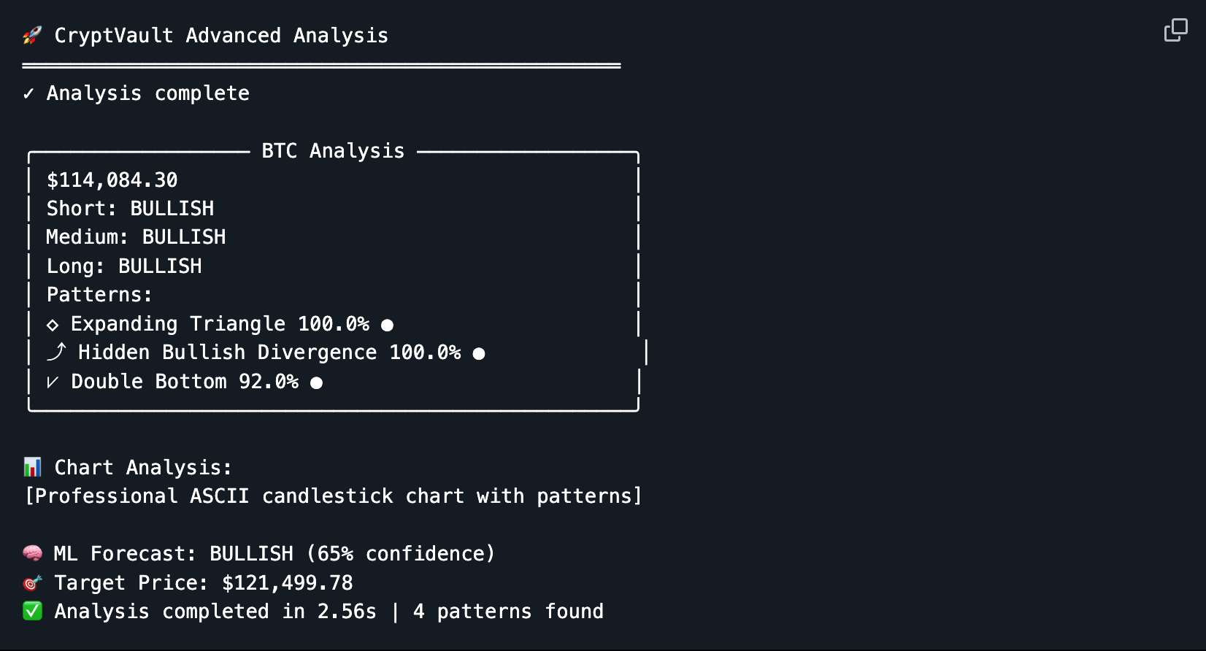
After running, you’ll see a trend summary with pattern matches and AI predictions, helping you make smarter, data-backed investment decisions in just seconds. 🚀

Thank you for reading Smart Cents Weekly
Continue your financial education journey with us next week.

Some quick financial legal stuff below ⬇️
The information provided herein is for informational and educational purposes only and does not constitute financial, investment, or trading advice. MeridianAlgo and the authors who wrote this document cannot be constituted as licensed financial advisors. We simply provide actionable insights to the world, increasing literacy and helping people. Always do your research and consult with a qualified financial advisor before making any investment decisions. Past performance is not indicative of future results. Investing involves risk, including the possible loss of principal.

Shameless plugs 😭
Website: http://meridianalgo.org
Github: https://github.com/MeridianAlgo
Tradingview: https://www.tradingview.com/
Donations: https://hcb.hackclub.com/donate

MeridianAlgo is a 501(c)(3) nonprofit with fiscal sponsorship from the Hack Club Foundation. We are dedicated to making financial literacy more accessible to youth. Since we don't make a profit or have a source of income, we rely on donations and grants from our local community to fund our operations and host events for many to enjoy. Whether it be at a library, event hall, or even online, we aim to ensure our generation can build wealth efficiently and smartly. Thank you.

